Name: A.Reddy Sulochana
Reg.No: 192372370

Exp.No.06 Vacuum Cleaner Problem
01.08.26

Aim:
To implement the Vacuum Cleaner Problem in Python and simulate the cleaning of dirty rooms.
Algorithm:
- Start the program.
- Read the status of Room A and Room B (Dirty or Clean).
- Read the starting location of the vacuum cleaner.
- If the current room is dirty, clean it.
- Move to the other room.
- If that room is dirty, clean it.
- Display the cleaning actions performed.
- Stop the program.

Program:
room = {}
room['A'] = input("Enter status of Room A (Dirty/Clean): ")
room['B'] = input("Enter status of Room B (Dirty/Clean): ")
location = input("Enter Vacuum Location (A/B): ").upper()
for i in range(2):
if room[location] == "Dirty":
print("Cleaning Room", location)
room[location] = "Clean"
else:
print("Room", location, "is already Clean")
if location == "A":
location = "B"
else:
location = "A"
print("Final Status:")
print(room)
Input:
Enter status of Room A (Dirty/Clean): Dirty
Enter status of Room B (Dirty/Clean): Clean
Enter Vacuum Location (A/B): A
Output:
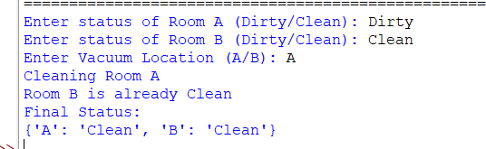

Result:
Thus, the Python program to implement the Vacuum Cleaner Problem was executed successfully, and all dirty rooms were cleaned.

